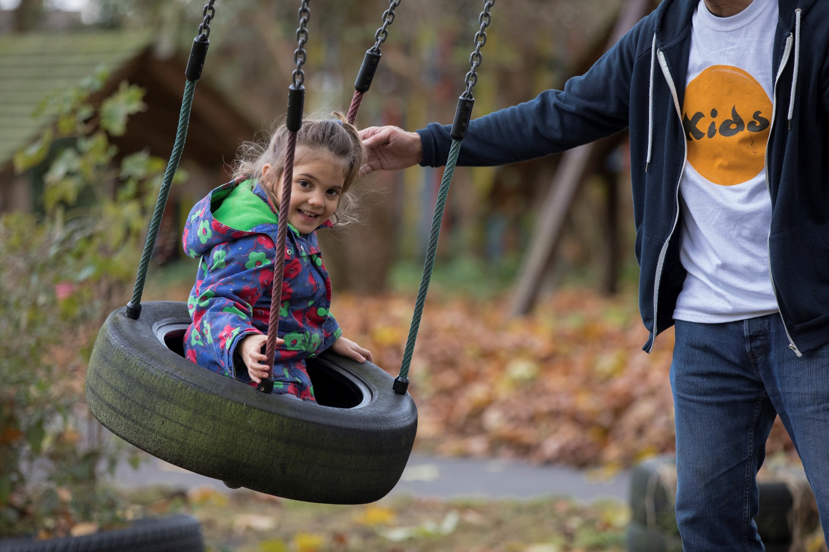

[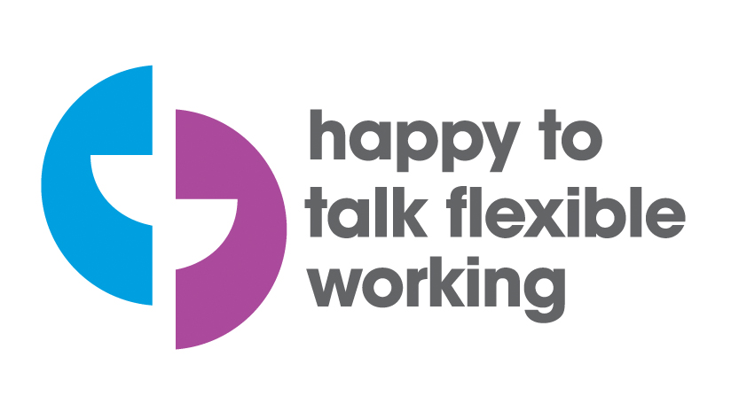](https://www.google.co.uk/url?sa=i&rct=j&q=&esrc=s&source=images&cd=&cad=rja&uact=8&ved=2ahUKEwifzaTAzfneAhXNy4UKHbOsAjMQjRx6BAgBEAU&url=https://www.workingfamilies.org.uk/campaigns/happy-to-talk-flexible-working/&psig=AOvVaw3-XN7Phb7F66a4vCme1nUi&ust=1543581010953262) Short Breaks Worker - Hackney

Are you looking for fun, flexible work that fits around your life? Want to work for an inspiring charity making a real difference to the lives of disabled children and young people?

As a Short Breaks Worker, you will be working directly with disabled children, or young people and their families, to support them with their needs. This is an opportunity to develop your skills in a rewarding role, and gain a strong sense of achievement.

Read further to find out about whether this role is right for you.

For more information about KIDS please visit [*www.kids.org.uk*](http://www.kids.org.uk).

**Our vision is a world in which all disabled children and young people realise their aspirations.**

**Our values underpin the work that we do with children, young people, and families in three main areas of their lives — we call these our “circles of support”.**

What We Do

KIDS are a national charity, founded over 48 years ago, providing a wide range of support services to disabled children, young people and their families. We support children with any disability from birth to 25 years of age. We also offer our support to the whole family with the aim of giving disabled children a brighter future.

*“Your involvement with my family has meant huge practical help during a difficult time. I think the key thing is that KIDS does stuff with and for the whole family, not just the child. I am sure that yours is the kind of service that helps prevent family break up as a result of the strains that a child with a disability brings.”*

We cannot change a diagnosis and we cannot cure but we can, and we do, make a very real difference to the lives of families with a disabled child through high quality, practical and tailored services delivered by dedicated professional staff.

KIDS provides over 120 different services and works with 80 local authorities throughout England. **In 2017-2018 we supported over 15,000 disabled children, young people and their families.**

***Our values***

*We are passionate*

*We are collaborative*

*We believe in quality*

*We are responsive*

*We are caring*

*We are trusted*

We are passionate about making a life-changing, positive difference to the lives of disabled children, young people and their families. Everything we do places the child at the centre of our support, our services then focus on providing care, which wraps around the child within their family.

To learn more about our corporate strategy, please visit [https://www.kids.org.uk/Pages/FAQs/Category/trustees](https://www.kids.org.uk/Handlers/Download.ashx?IDMF=3932febd-4752-4300-a6d7-a222662d7260).

.

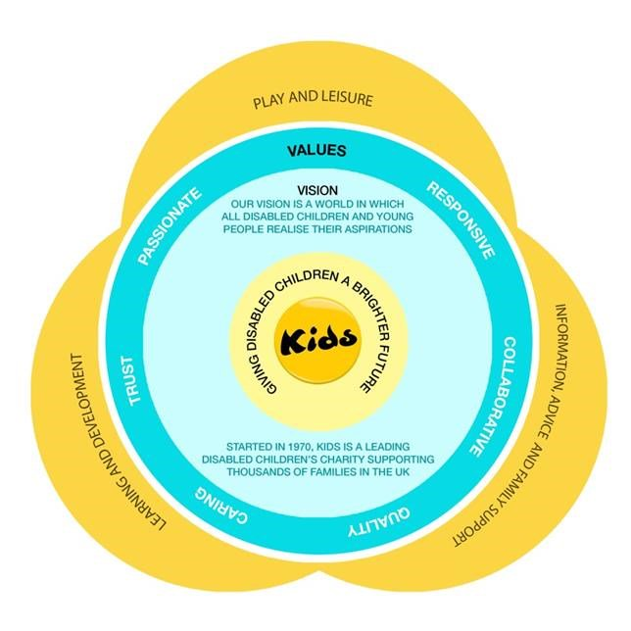

**‘Being given the opportunity to make a positive impact on a young person’s life’ - Ollie, Assistant Practitioner**

What You Can Expect

**Our services**

KIDS was established in 1970 by John Mulcahy, a teacher who had become concerned about the development of a disabled child in one of his classes.  Looking to improve communication with the child.

John turned to the child’s mother for guidance. This sowed the seeds of working in partnership with parents and carers to enable disabled children and young people to develop their skills and abilities and to fulfil their potential, hopes and dreams.

KIDS are a charity which has pioneered a number of approaches and programmes for disabled children and young people. These include Home Learning (Portage), Parent Partnerships, Adventure Playgrounds and the inclusion of disabled children in mainstream educational settings.

KIDS has a rich history and vast experience of meeting the needs of disabled children and young people and families. Therefore, KIDS is well-placed to play a leading role supporting the development of policy affecting this important group in society.

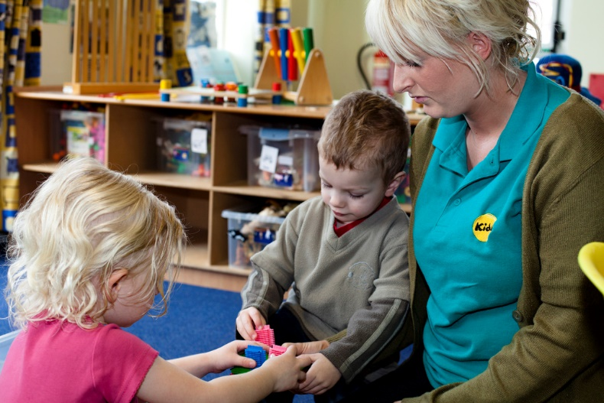

**Our benefits**

Here at KIDS we want you to know that you are valued, and that we are committed to your safety and wellbeing. Our benefits include:

* Access to KIDS Virtual College: our wide range of interactive e-learning training courses which carry CPD points
* Strong sense of achievement from meaningful work
* Generous holiday pay
* Work-life balance and flexibility in working
* 24 hour helpline to deal with safeguarding issues

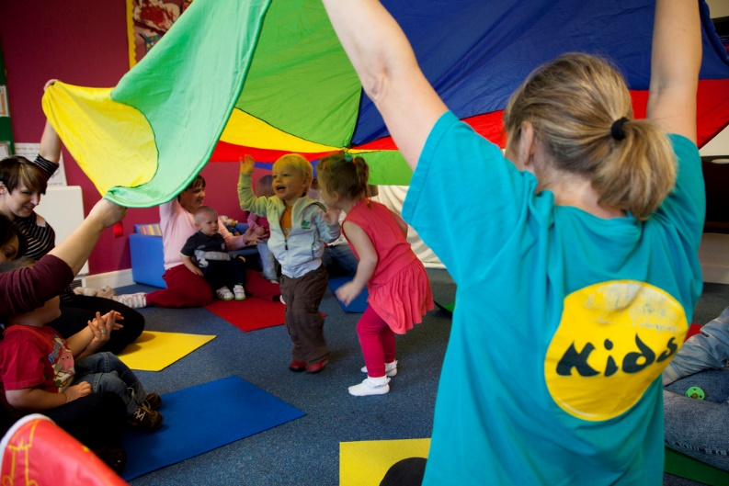

Safeguarding

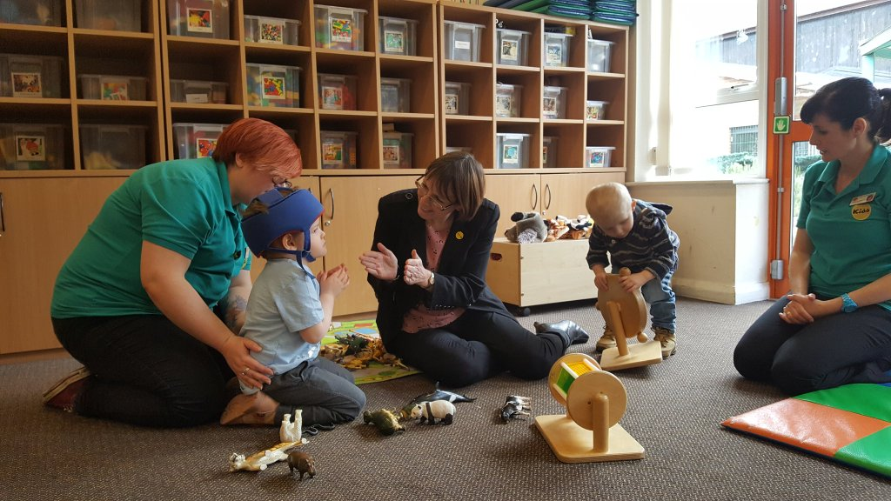

KIDS are committed to safeguarding and promoting the welfare of children and young people and expects all staff and volunteers to share this commitment. All children and young people we work with must, at all times, feel safe.

As part of our commitment to safeguarding KIDS has a safeguarding board with representatives from all parts of the organisation. The board meets regularly to review policy and practice as well as to disseminate learning and good practice. KIDS have a designated safeguarding lead at director and at trustee level.

KIDS follow safer recruitment principles and all staff and volunteers working with children, young people or their families have DBS checks, regular supervision and also safeguarding training.

We work closely with families and co-operate fully with other agencies to take all reasonable steps to minimise the risks of harm to a child or young person’s wellbeing. We recognise that whilst not all risks can be eliminated, we must operate in an atmosphere of safe uncertainty. This means that children and young people must feel secure and safe in the face of reasonable risks, but should never be knowingly or unknowingly put in a position of significant harm or abuse.

**KIDS Safeguarding Board acts in an advisory capacity to monitor and continuously improve safeguarding practices throughout the organisation. To read our safeguarding policies, please clink on the links below:**

[Safeguarding Children and Young People Policy](https://www.kids.org.uk/Handlers/Download.ashx?IDMF=96bec99d-27e7-439c-933e-87efa9dbc5ea)

[Safeguarding Vulnerable Adults Policy](https://www.kids.org.uk/Handlers/Download.ashx?IDMF=867ffc56-e034-4584-a2f4-e6a6ddbd34b7)

[Disclosure and Barring Service Policy](https://www.kids.org.uk/Handlers/Download.ashx?IDMF=6118c54d-7a3c-4306-abe2-419335a10d1d)

Job Description

**Overall Purpose of Role**

To provide short breaks for disabled children and young people, supporting them to access a variety of activities, promoting independence, inclusion and learning, and engaging positive activities. Whilst working in a person centred way, providing practical and emotional support to the child or young person, to enable them to meet the goals and outcomes identified in their support plan.

Short breaks are on a 1:1 basis in the community and in a child or young person’s home. Our breaks are designed around the child or young person and their interests and hobbies, so during a break you may take a child swimming, to a local park, or perhaps to the shops.

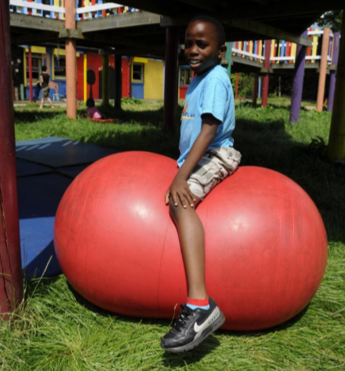

**Key Relationships**

You will be building relationships both internally and externally at KIDS. Developing relationships with disabled children and young people, as well as their parents and carers, will be a huge part of this role. It may also be necessary to work with professionals who work with families, mainstream service providers and specialist leisure services.

At KIDS, you will also be working alongside Senior Practitioners, Coordinators, and Service Managers, to provide a holistic service to service users.

**Working Context**

* You will be required to work variable/ unsociable hours which may include evenings, weekends, and bank holidays
* There is some physical moving and lifting of children and most children wish to participate in active leisure activities.
* Occasional travel may be required
* Your role will be subject to an enhanced DBS check
* Your role may involve working in a regulated activity

**Child Centred Approach**

1. To deliver high quality breaks to children and young people, where they access activities of their choice and promoting inclusion, ensuring their safety and wellbeing at all times.
2. To recognise and meet the child or young person’s social, emotional, and communication needs, doing so in a manner that is sensitive to the Religious, Cultural, Linguistic and Ethnic origins of the individual.
3. To demonstrate effective communication skills including adapting communications styles to the individual, report/observation writing, verbal, non-verbal and advocacy awareness.
4. To consult and involve the child in all decisions affecting him/her using whatever means are appropriate and possible.
5. To work in partnership with children/young people, promoting their voice and supporting their active participation in the design of services.
6. To provide personal care and support in accordance with the individual’s needs and/or preferences, as stated in their care and support plan, in a manner which demonstrates dignity and respect at all times. This may involve aspects of personal care, administration of medicine and acting in a medical emergency.
7. Recognise the importance of commitment and reliability to ensure continuity for the child or young person, and develop a working knowledge of the child and their needs including key information, their care plan, medication and risk assessments.
8. To work across all departments support the region and all teams to deliver a high quality provision to children, young people and families.
9. To undertake other duties at the request of the Short Breaks Coordinator or other senior manager as far as they are compatible with he aims and level of responsibility of the post.

Key Responsibilities

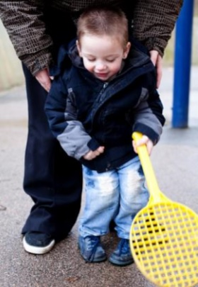

Key Responsibilities

**‘The staff are really friendly and create a nice atmosphere to work in’ - Sarah, Assistant Practitioner**

**Safeguarding Policies and Procedures**

1. To be familiar with and fully comply with all KIDS policies and procedures including child protection, safeguarding, health and safety, confidentiality and partnership.
2. To work within the standards required by relevant regularity bodies.
3. To ensure that the safeguarding and risk for each child or young person is reviewed regularly.
4. To safeguard the health, wellbeing and safety of the children and young people, and if any concerns arise, to immediately report any concerns in line with KIDS policies and procedures.

**Other Responsibilities**

You are responsible for maintaining the confidentiality of materials from all systems both electronic and paper and you may not remove from the premises any hardware, software, files, photographs or data without written permission unless agreed by your Line Manager/ equivalent as part of the execution of your normal duties.

Sharing the responsibility for ensuring that the organisation stays in touch and synchronised across the country.

To record each visit to the child in line with KIDS guidelines and notify Service Coordinator of any incidences.

To complete appropriate administration connected to the support provided: daily activity notes, accident reports, medication administration records.

To attend supervision and team meetings to meet KIDS policies and procedures.

To attend KIDSinduction and on-going in-service training programmes. Including undertaking additional training when necessary to meet the needs of the C&YP.

Develop appropriate skills to support and enable disabled children/young people to engage in the provided activities through observation and shadowing experienced staff, where appropriate.

To attend, if required, review meetings, team around the child/family meetings and any other statutory meetings.

**KIDS is committed to safeguarding and promoting the welfare of children and young people and also expects for all staff and volunteers to share this commitment. All children and young people we work with must, at all times, feel safe.**

Person Specification

**Proven Ability**

To be able to carry out this role we would expect you to have the following characteristics:

* Experience of working with disabled children is desirable but not essential.
* Demonstrate an understanding of the needs of disabled children and young people and a commitment to safeguarding.
* Strong interpersonal skills.
* Ability to work on your own and use initiative.
* Available to work regular evenings and weekends.
* Drive, commitment and enthusiasm.
* Effective communication skills including adapting communication styles to the individual, report/observation writing, verbal, non-verbal and advocacy awareness.
* Willing to provide personal care and support in accordance with the child or young person’s needs and preferences, as stated in their care and support plan.

**Education/Qualifications**

* Childcare qualifications at NVQ or an equivalent level is desirable for this role.
* Whilst not essential, it is desirable if you have a paediatric first aid certificate and/or moving and handling training.
* You may require a driving licence. If you will be using a car for short breaks, then business insurance is also essential.

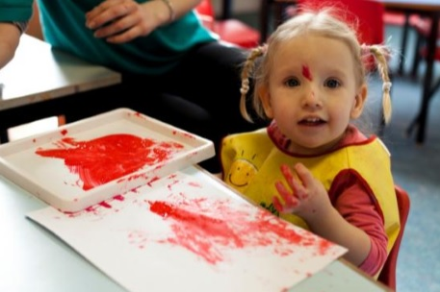

**Thank you for choosing KIDS. We look forward to receiving your application.**