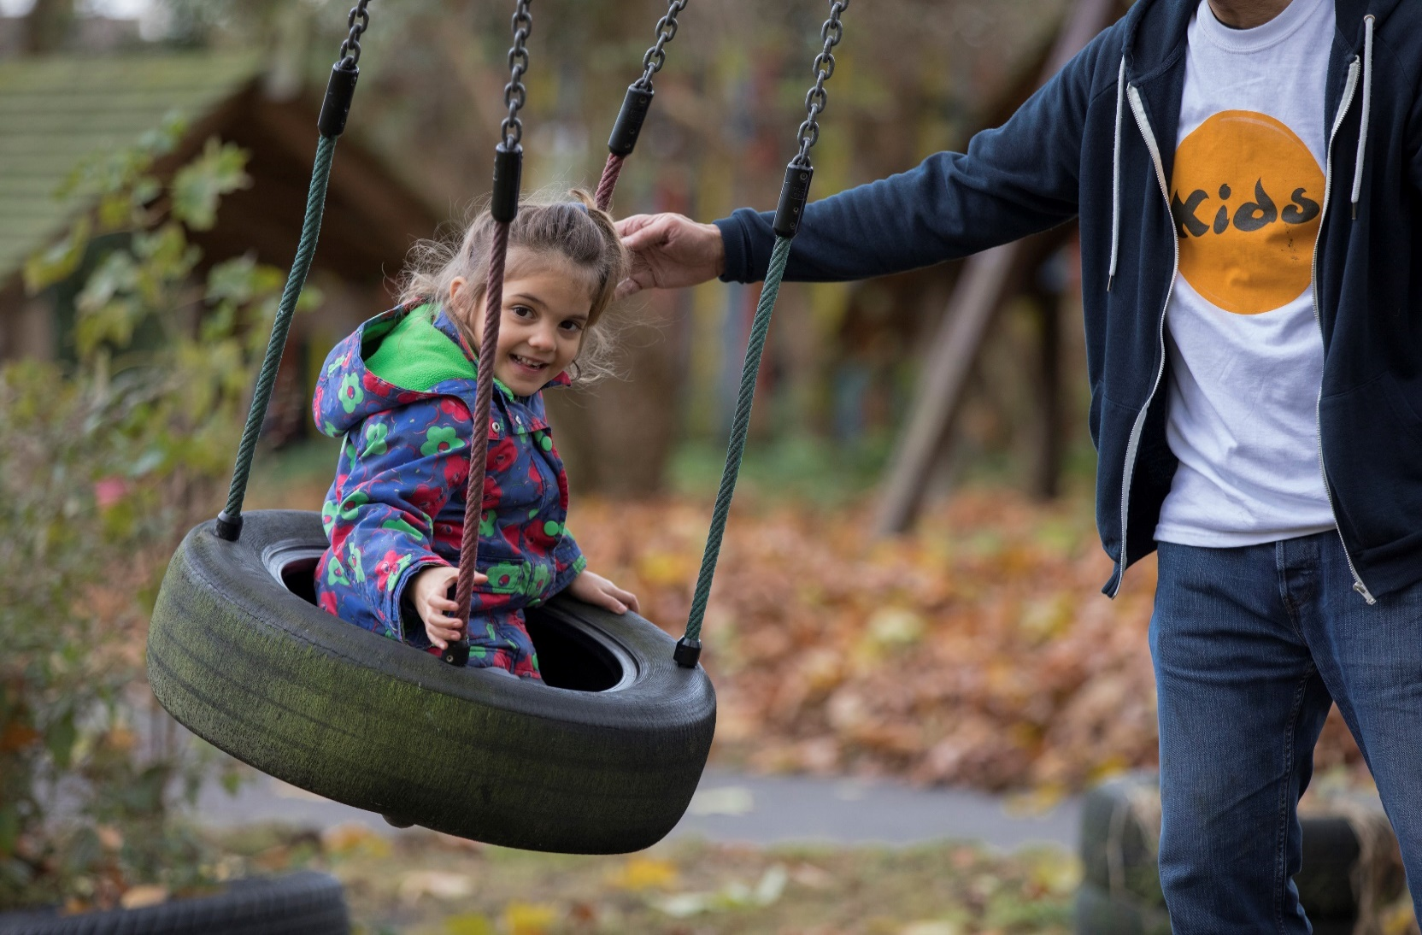

Senior Practitioner

This is a permanent post.

As a Senior Practitioner you will be supporting disabled children, young people and their families accessing our services. This is a great opportunity to develop your skills in a rewarding role, and gain a strong sense of achievement.

Read further to find out about whether this role is right for you.

For more information about KIDS please visit *[www.kids.org.uk](http://www.kids.org.uk)*.

**‘Being given the opportunity to make a positive impact on a young person’s life’ - Ollie, Assistant Practitioner**

**Our vision is a world in which all disabled children and young people realise their aspirations.**

**Overall Purpose of Role**

To deliver an accredited Portage early intervention service for disabled children under 5 years old in the child’s home. To create a partnership with parents in providing a structured programme of child-led play and family support.



**Key Relationships**

Internal

Co-ordinator, Portage trainers, Other Home Learning workers

External

Portage workers, Disabled children, Families, Health professionals, Education professionals, Social Care professionals, Children Centres, Other voluntary and private sector providers

**Working Context**

* You will be required to perform tasks as required commensurate with your grade and experience
* Your role may be subject to an enhanced DBS check
* Your role may involve working in a regulated activity
* You will be required to travel within a limited geographical area with occasional travel outside that area
* You will be required to work on your own within the family home
* You will be required to work flexibly to meet the requirements of families, Portage and Local Authorities
* You will be required to manage your own caseload

Key Responsibilities

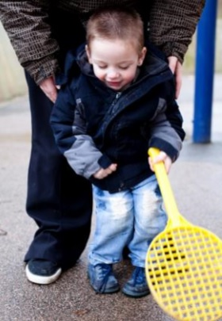

* Build partnership with parents
* Make regular weekly visits to family homes
* With the Coordinator or another member of the team run a weekly Portage group
* Manage own case work
* Set our intervention plans to include – weekly activities, reviewing progress and producing relevant written reports
* Keep accurate records
* Co-ordinate/attend Co-production meetings
* Contribute to/initiate Common Assessment Framework
* Participate in Multidisciplinary assessments and interventions
* Contribute to KIDS Portage network
* Undertake project specific activities as outlined on the addendum
* Understand and comply with all relevant legislation, policies and procedures for working with children
* Participation in own supervision and Continuing Professional Development
* Autonomy
* Finding their way around a discreet geographical area
* Responsible for all the direct work undertaken with the child and family
* Ensuring that all equipment meets Health & Safety requirements

Key Responsibilities

**‘The staff are really friendly and create a nice atmosphere to work in’ - Sarah, Assistant Practitioner**

**Safeguarding Policies and Procedures**

1. To be familiar with and fully comply with all KIDS policies and procedures including child protection, safeguarding, health and safety, confidentiality and partnership.
2. To work within the standards required by relevant regularity bodies.
3. To ensure that the safeguarding and risk for each child or young person is reviewed regularly.
4. To safeguard the health, wellbeing and safety of the children and young people, and if any concerns arise, to immediately report any concerns in line with KIDS policies and procedures.

**Other Responsibilities**

You are responsible for maintaining the confidentiality of materials from all systems both electronic and paper and you may not remove from the premises any hardware, software, files, photographs or data without written permission unless agreed by your Line Manager/ equivalent as part of the execution of your normal duties.

Sharing the responsibility for ensuring that the organisation stays in touch and synchronised across the country.

**KIDS is committed to safeguarding and promoting the welfare of children and young people and also expects for all staff and volunteers to share this commitment. All children and young people we work with must, at all times, feel safe.**

Person Specification

**Proven Ability**

To be able to carry out this role it is essential that you have the following characteristics:

* Thorough knowledge of early year’s child development
* Understanding and use of developmental tools for assessing children
* Experience of working with parents with their disabled children birth to 5 years
* Experience of structuring children’s learning
* Ability to write reports
* Using email and office software product
* Ability to leave clear and legible notes for parents
* Experience of managing own case work
* Anti- discriminatory practice
* Understanding of current Safeguarding processes

**Desirable criteria**

To be able to carry out this role it is desirable that you have the following characteristics:

• Experience of working multi-cultural context

• Knowledge of early year’s educational processes and services

• Experience of working in family homes

• Understanding of current legislation relevant to this work

**Education/Qualifications**

* NVQIII or an equivalent in early years education

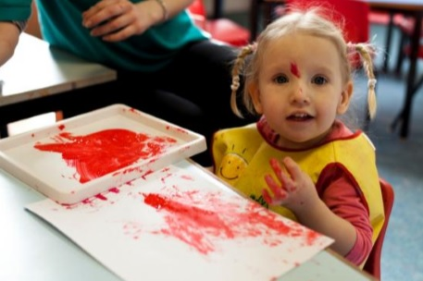

**Thank you for choosing KIDS. We look forward to receiving your application.**